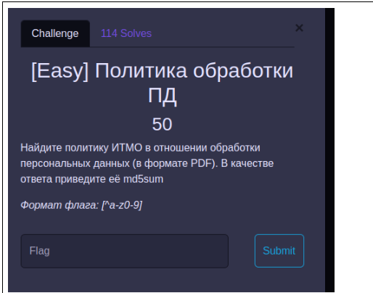

| ctfclub{5P3edH@} |
| --- |
| 0c490bbac7c2601ed7bbd8bdb3bcd61cb3128d39b3a5553eec829af91d29cfe2b29f364958aa982aaf5daa1392785fd2 |
| fabd8a56afc168067fd698b912be6ae89db43a1494decea313a9af084a85427e1fc1a864be71bfef136fea492a542e7d |
|  |
| ctfclub{d15400bdb9a30cbd686961d4b20de6ff} |
| ctfclub{566863e59f5082b404a1184ac7e59290} |
| 87e5d25b5afdac4bb209b7be38ba5967 |
| ctfclub{ozernaya_1a} |
| ctfclub{YOuhaVeF0UndTH3fiL3C0N6ra7$} |
| ctfclub{THiS0N3i5V3RYUn!9uEf!Le} |
|  |
| ctfclub{7OoManYVuLnER481LIT!3s} |
| ctfclub{happybirthdaydearadmin} |
| ctfclub{THiS0N3i5V3RYUn!9uEf!Le} |
| itmo{1234567890} |
| CTFCLUB{fL0at_1s_daNg3roUs} |
| CTFCLUB{th3_wRoNg_oRGan1zEr5_4Re_d0inG_tH3_WROng_t4sKS} |